21BDS0340

Abhinav Dinesh Srivatsa

Computer Networks Lab

Assignment – IV

**Question 1**

Aim:

Implement the Stop and Wait protocol without timer

Output:

**StopAndWaitServer.java**

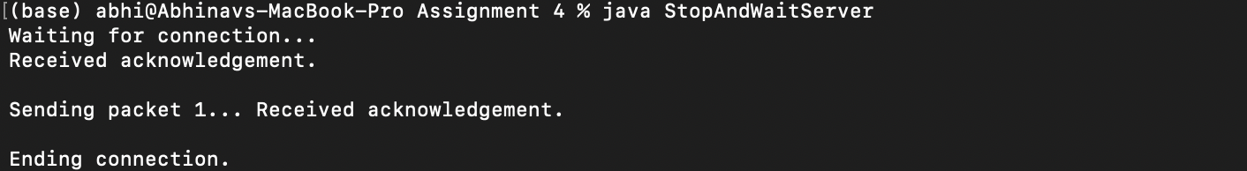

**StopAndWaitClient.java**

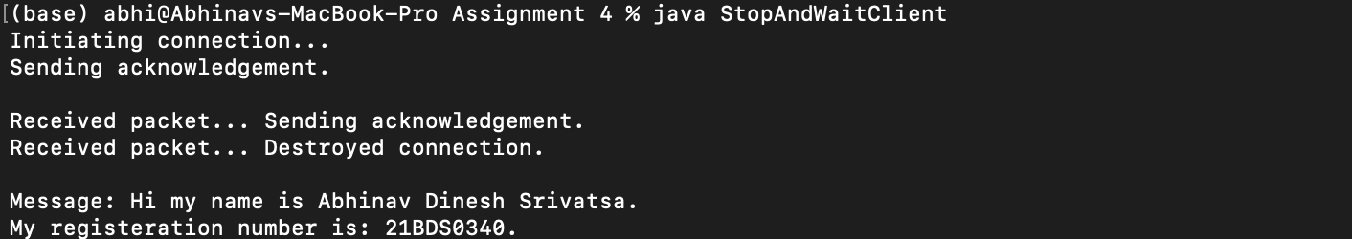

Code:

**StopAndWaitServer.java**

import java.io.IOException;

import java.io.UnsupportedEncodingException;

import java.net.DatagramPacket;

import java.net.DatagramSocket;

import java.net.InetAddress;

import java.util.Arrays;

public class StopAndWaitServer {

private static final int PACKET_SIZE = 1024;

private InetAddress address;

private DatagramSocket socket;

private int port;

public StopAndWaitServer(int port) throws IOException {

this.port = port;

this.socket = new DatagramSocket(port);

}

private char[] stringToCharArray(String dataString) {

String middle = dataString.substring(1, dataString.length() - 1);

String elementsString[] = middle.split(", ");

char elementsInt[] = new char[elementsString.length];

for (int x = 0; x < elementsString.length; x++)

elementsInt[x] = (char) Integer.parseInt(elementsString[x]);

return elementsInt;

}

private byte[] stringToByteArray(String dataString) throws UnsupportedEncodingException {

return dataString.getBytes("UTF-8");

}

private char[] receivePacket() throws IOException {

byte data[] = new byte[PACKET_SIZE];

DatagramPacket packet = new DatagramPacket(data, data.length);

socket.receive(packet);

System.out.println("Received acknowledgement.");

this.address = packet.getAddress();

this.port = packet.getPort();

return stringToCharArray(Arrays.toString(data));

}

private void sendPacket(String dataString) throws IOException {

byte dataByte[] = stringToByteArray(dataString);

DatagramPacket packet = new DatagramPacket(dataByte, dataByte.length,

this.address, this.port);

socket.send(packet);

}

private boolean checkAck(int expectedPacketNumber, char data[]) {

return ((char) expectedPacketNumber) == (data[0] - '0');

}

private void sendData(String dataString) throws IOException {

int packetNumber = 1;

for (int x = 0; x <= dataString.length() / 1023; x++) {

String data = Integer.toString(packetNumber);

if (x + PACKET_SIZE - 1 < dataString.length() - 1)

data += dataString.substring(x, x + PACKET_SIZE - 1);

else

data += dataString.substring(x, dataString.length());

boolean ack = false;

while (!ack) {

System.out.print("Sending packet " + packetNumber + "... ");

sendPacket(data);

char response[] = receivePacket();

ack = checkAck(packetNumber, response);

}

packetNumber++;

}

sendPacket("");

}

public static void main(String[] args) throws IOException {

int port = 5000;

String data = "Hi my name is Abhinav Dinesh Srivatsa.\nMy registeration number is: 21BDS0340.";

StopAndWaitServer saws = new StopAndWaitServer(port);

System.out.println("Waiting for connection... ");

saws.receivePacket();

System.out.println();

saws.sendData(data);

System.out.println("\nEnding connection.");

}

}

**StopAndWaitClient.java**

import java.io.IOException;

import java.io.UnsupportedEncodingException;

import java.net.DatagramPacket;

import java.net.DatagramSocket;

import java.net.InetAddress;

import java.net.SocketException;

import java.util.Arrays;

public class StopAndWaitClient {

private static final int PACKET_SIZE = 1024;

private InetAddress address;

private DatagramSocket socket;

private int port;

public StopAndWaitClient(InetAddress address, int port) throws SocketException {

this.port = port;

this.address = address;

socket = new DatagramSocket();

}

private byte[] stringToByteArray(String dataString) throws UnsupportedEncodingException {

return dataString.getBytes("UTF-8");

}

private char[] stringToCharArray(String dataString) {

String middle = dataString.substring(1, dataString.length() - 1);

String elementsString[] = middle.split(", ");

char elementsChar[] = new char[elementsString.length];

for (int x = 0; x < elementsString.length; x++)

elementsChar[x] = (char) Integer.parseInt(elementsString[x]);

return elementsChar;

}

public void sendPacket(String dataString) throws IOException {

byte data[] = stringToByteArray(dataString);

DatagramPacket packet = new DatagramPacket(data, data.length, address, port);

System.out.println("Sending acknowledgement.");

socket.send(packet);

}

public char[] receivePacket() throws IOException {

byte data[] = new byte[PACKET_SIZE];

DatagramPacket packet = new DatagramPacket(data, data.length);

socket.receive(packet);

return stringToCharArray(Arrays.toString(data));

}

public String[] receiveTransmission() throws IOException {

String messages[] = new String[10];

for (int x = 1; x < messages.length; x++) {

char data[] = receivePacket();

System.out.print("Received packet... ");

if (data[0] == '\0')

break;

messages[x] = new String(data);

String index = messages[x].substring(0, 1);

messages[x] = messages[x].substring(1, messages[x].length() - 1);

sendPacket(index);

}

System.out.println("Destroyed connection.\n");

return messages;

}

public static void main(String[] args) throws IOException {

InetAddress address = InetAddress.getByName("localhost");

int port = 5000;

StopAndWaitClient sawc = new StopAndWaitClient(address, port);

System.out.println("Initiating connection...");

sawc.sendPacket("initiate");

System.out.println();

String messages[] = sawc.receiveTransmission();

for (int x = 1; x < messages.length; x++)

if (messages[x] != null)

System.out.println("Message: " + messages[x]);

}

}

**Question 2**

Aim:

Implement the Stop and Wait protocol with Time ARQ (Automatic Repeat Query/ Request)

Output:

**StopAndWaitARQServer.java**

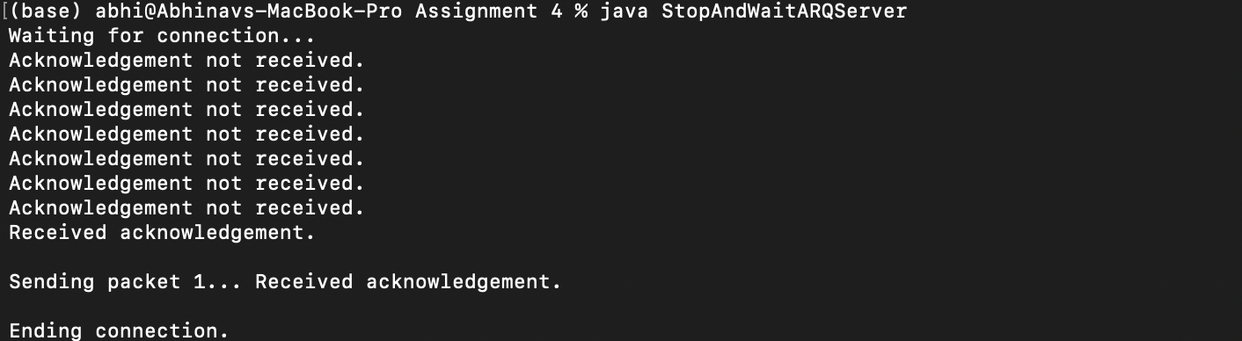

**StopAndWaitClient.java**



Code:

**StopAndWaitARQServer.java**

import java.io.IOException;

import java.io.UnsupportedEncodingException;

import java.net.DatagramPacket;

import java.net.DatagramSocket;

import java.net.InetAddress;

import java.util.Arrays;

public class StopAndWaitARQServer {

private static final int PACKET_SIZE = 1024, TIMEOUT = 3000;

private InetAddress address;

private DatagramSocket socket;

private int port;

public StopAndWaitARQServer(int port) throws IOException {

this.port = port;

this.socket = new DatagramSocket(port);

this.socket.setSoTimeout(TIMEOUT);

}

private char[] stringToCharArray(String dataString) {

String middle = dataString.substring(1, dataString.length() - 1);

String elementsString[] = middle.split(", ");

char elementsChar[] = new char[elementsString.length];

for (int x = 0; x < elementsString.length; x++)

elementsChar[x] = (char) Integer.parseInt(elementsString[x]);

return elementsChar;

}

private byte[] stringToByteArray(String dataString) throws UnsupportedEncodingException {

return dataString.getBytes("UTF-8");

}

private char[] receivePacket() {

byte data[] = new byte[PACKET_SIZE];

DatagramPacket packet = new DatagramPacket(data, data.length);

while (stringToCharArray(Arrays.toString(data))[0] == '\0')

try {

socket.receive(packet);

} catch (IOException e) {

System.out.println("Acknowledgement not received.");

}

System.out.println("Received acknowledgement.");

this.address = packet.getAddress();

this.port = packet.getPort();

return stringToCharArray(Arrays.toString(data));

}

private void sendPacket(String dataString) throws IOException {

byte dataByte[] = stringToByteArray(dataString);

DatagramPacket packet = new DatagramPacket(dataByte, dataByte.length,

this.address, this.port);

socket.send(packet);

}

private boolean checkAck(int expectedPacketNumber, char data[]) {

return ((char) expectedPacketNumber) == (data[0] - '0');

}

private void sendData(String dataString) throws IOException {

int packetNumber = 1;

for (int x = 0; x <= dataString.length() / 1023; x++) {

String data = Integer.toString(packetNumber);

if (x + PACKET_SIZE - 1 < dataString.length() - 1)

data += dataString.substring(x, x + PACKET_SIZE - 1);

else

data += dataString.substring(x, dataString.length());

boolean ack = false;

while (!ack) {

System.out.print("Sending packet " + packetNumber + "... ");

sendPacket(data);

char response[] = {};

response = receivePacket();

ack = checkAck(packetNumber, response);

}

packetNumber++;

}

sendPacket("");

}

public static void main(String[] args) throws IOException {

int port = 5000;

String data = "Hi my name is Abhinav Dinesh Srivatsa.\nMy registeration number is: 21BDS0340.";

StopAndWaitARQServer saws = new StopAndWaitARQServer(port);

System.out.println("Waiting for connection... ");

saws.receivePacket();

System.out.println();

saws.sendData(data);

System.out.println("\nEnding connection.");

}

}

**StopAndWaitClient.java**

import java.io.IOException;

import java.io.UnsupportedEncodingException;

import java.net.DatagramPacket;

import java.net.DatagramSocket;

import java.net.InetAddress;

import java.net.SocketException;

import java.util.Arrays;

public class StopAndWaitClient {

private static final int PACKET_SIZE = 1024;

private InetAddress address;

private DatagramSocket socket;

private int port;

public StopAndWaitClient(InetAddress address, int port) throws SocketException {

this.port = port;

this.address = address;

socket = new DatagramSocket();

}

private byte[] stringToByteArray(String dataString) throws UnsupportedEncodingException {

return dataString.getBytes("UTF-8");

}

private char[] stringToCharArray(String dataString) {

String middle = dataString.substring(1, dataString.length() - 1);

String elementsString[] = middle.split(", ");

char elementsChar[] = new char[elementsString.length];

for (int x = 0; x < elementsString.length; x++)

elementsChar[x] = (char) Integer.parseInt(elementsString[x]);

return elementsChar;

}

public void sendPacket(String dataString) throws IOException {

byte data[] = stringToByteArray(dataString);

DatagramPacket packet = new DatagramPacket(data, data.length, address, port);

System.out.println("Sending acknowledgement.");

socket.send(packet);

}

public char[] receivePacket() throws IOException {

byte data[] = new byte[PACKET_SIZE];

DatagramPacket packet = new DatagramPacket(data, data.length);

socket.receive(packet);

return stringToCharArray(Arrays.toString(data));

}

public String[] receiveTransmission() throws IOException {

String messages[] = new String[10];

for (int x = 1; x < messages.length; x++) {

char data[] = receivePacket();

System.out.print("Received packet... ");

if (data[0] == '\0')

break;

messages[x] = new String(data);

String index = messages[x].substring(0, 1);

messages[x] = messages[x].substring(1, messages[x].length() - 1);

sendPacket(index);

}

System.out.println("Destroyed connection.\n");

return messages;

}

public static void main(String[] args) throws IOException {

InetAddress address = InetAddress.getByName("localhost");

int port = 5000;

StopAndWaitClient sawc = new StopAndWaitClient(address, port);

System.out.println("Initiating connection...");

sawc.sendPacket("initiate");

System.out.println();

String messages[] = sawc.receiveTransmission();

for (int x = 1; x < messages.length; x++)

if (messages[x] != null)

System.out.println("Message: " + messages[x]);

}

}

**Question 3**

Aim:

Implement the Sliding window protocol (General way)

Output:

**SlidingWindowGeneralServer.java**

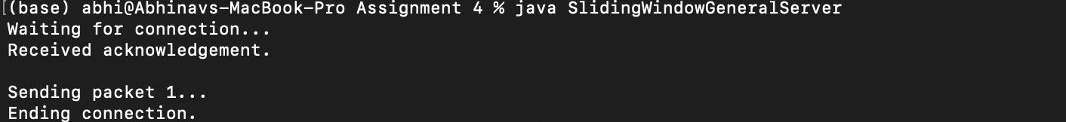

**SlidingWindowGeneralClient.java**

Code:

**SlidingWindowGeneralServer.java**

import java.io.IOException;

import java.io.UnsupportedEncodingException;

import java.net.DatagramPacket;

import java.net.DatagramSocket;

import java.net.InetAddress;

import java.util.Arrays;

public class SlidingWindowGeneralServer {

private static final int PACKET_SIZE = 1024;

private InetAddress address;

private DatagramSocket socket;

private int port;

public SlidingWindowGeneralServer(int port) throws IOException {

this.port = port;

this.socket = new DatagramSocket(port);

}

private char[] stringToCharArray(String dataString) {

String middle = dataString.substring(1, dataString.length() - 1);

String elementsString[] = middle.split(", ");

char elementsInt[] = new char[elementsString.length];

for (int x = 0; x < elementsString.length; x++)

elementsInt[x] = (char) Integer.parseInt(elementsString[x]);

return elementsInt;

}

private byte[] stringToByteArray(String dataString) throws UnsupportedEncodingException {

return dataString.getBytes("UTF-8");

}

private char[] receivePacket() throws IOException {

byte data[] = new byte[PACKET_SIZE];

DatagramPacket packet = new DatagramPacket(data, data.length);

socket.receive(packet);

System.out.println("Received acknowledgement.");

this.address = packet.getAddress();

this.port = packet.getPort();

return stringToCharArray(Arrays.toString(data));

}

private void sendPacket(String dataString) throws IOException {

byte dataByte[] = stringToByteArray(dataString);

DatagramPacket packet = new DatagramPacket(dataByte, dataByte.length,

this.address, this.port);

socket.send(packet);

}

private void sendData(String dataString) throws IOException {

int packetNumber = 1;

for (int x = 0; x <= dataString.length() / 1023; x++) {

String data = Integer.toString(packetNumber);

if (x + PACKET_SIZE - 1 < dataString.length() - 1)

data += dataString.substring(x, x + PACKET_SIZE - 1);

else

data += dataString.substring(x, dataString.length());

System.out.print("Sending packet " + packetNumber + "... ");

sendPacket(data);

packetNumber++;

}

sendPacket("");

}

public static void main(String[] args) throws IOException {

int port = 5000;

String data = "Hi my name is Abhinav Dinesh Srivatsa.\nMy registeration number is: 21BDS0340.";

SlidingWindowGeneralServer swgs = new SlidingWindowGeneralServer(port);

System.out.println("Waiting for connection... ");

swgs.receivePacket();

System.out.println();

swgs.sendData(data);

System.out.println("\nEnding connection.");

}

}

**SlidingWindowGeneralClient.java**

import java.io.IOException;

import java.io.UnsupportedEncodingException;

import java.net.DatagramPacket;

import java.net.DatagramSocket;

import java.net.InetAddress;

import java.net.SocketException;

import java.util.Arrays;

public class SlidingWindowGeneralClient {

private static final int PACKET_SIZE = 1024;

private InetAddress address;

private DatagramSocket socket;

private int port;

public SlidingWindowGeneralClient(InetAddress address, int port) throws SocketException {

this.port = port;

this.address = address;

socket = new DatagramSocket();

}

private byte[] stringToByteArray(String dataString) throws UnsupportedEncodingException {

return dataString.getBytes("UTF-8");

}

private char[] stringToCharArray(String dataString) {

String middle = dataString.substring(1, dataString.length() - 1);

String elementsString[] = middle.split(", ");

char elementsChar[] = new char[elementsString.length];

for (int x = 0; x < elementsString.length; x++)

elementsChar[x] = (char) Integer.parseInt(elementsString[x]);

return elementsChar;

}

public void sendPacket(String dataString) throws IOException {

byte data[] = stringToByteArray(dataString);

DatagramPacket packet = new DatagramPacket(data, data.length, address, port);

System.out.println("Sending acknowledgement.");

socket.send(packet);

}

public char[] receivePacket() throws IOException {

byte data[] = new byte[PACKET_SIZE];

DatagramPacket packet = new DatagramPacket(data, data.length);

socket.receive(packet);

return stringToCharArray(Arrays.toString(data));

}

public String[] receiveTransmission() throws IOException {

String messages[] = new String[10];

for (int x = 1; x < messages.length; x++) {

char data[] = receivePacket();

System.out.print("Received packet... ");

if (data[0] == '\0')

break;

messages[x] = new String(data);

String index = messages[x].substring(0, 1);

messages[x] = messages[x].substring(1, messages[x].length() - 1);

sendPacket(index);

}

System.out.println("Destroyed connection.\n");

return messages;

}

public static void main(String[] args) throws IOException {

InetAddress address = InetAddress.getByName("localhost");

int port = 5000;

SlidingWindowGeneralClient swgc = new SlidingWindowGeneralClient(address, port);

System.out.println("Initiating connection...");

swgc.sendPacket("initiate");

System.out.println();

String messages[] = swgc.receiveTransmission();

for (int x = 1; x < messages.length; x++)

if (messages[x] != null)

System.out.println("Message: " + messages[x]);

}

}

**Question 4**

Aim:

Implement the go back N protocol

Output:

**SlidingWindowGoBackNServer.java**



**SlidingWindowGoBackNClient.java**

Code:

**SlidingWindowGoBackNServer.java**

import java.io.IOException;

import java.io.UnsupportedEncodingException;

import java.net.DatagramPacket;

import java.net.DatagramSocket;

import java.net.InetAddress;

import java.util.Arrays;

public class SlidingWindowGoBackNServer {

private static final int PACKET_SIZE = 1024;

private InetAddress address;

private DatagramSocket socket;

private int port;

public SlidingWindowGoBackNServer(int port) throws IOException {

this.port = port;

this.socket = new DatagramSocket(port);

}

private char[] stringToCharArray(String dataString) {

String middle = dataString.substring(1, dataString.length() - 1);

String elementsString[] = middle.split(", ");

char elementsInt[] = new char[elementsString.length];

for (int x = 0; x < elementsString.length; x++)

elementsInt[x] = (char) Integer.parseInt(elementsString[x]);

return elementsInt;

}

private byte[] stringToByteArray(String dataString) throws UnsupportedEncodingException {

return dataString.getBytes("UTF-8");

}

private char[] receivePacket() throws IOException {

byte data[] = new byte[PACKET_SIZE];

DatagramPacket packet = new DatagramPacket(data, data.length);

socket.receive(packet);

System.out.println("Received acknowledgement.");

this.address = packet.getAddress();

this.port = packet.getPort();

return stringToCharArray(Arrays.toString(data));

}

private void sendPacket(String dataString) throws IOException {

byte dataByte[] = stringToByteArray(dataString);

DatagramPacket packet = new DatagramPacket(dataByte, dataByte.length,

this.address, this.port);

socket.send(packet);

}

private void sendData(String dataString) throws IOException {

int packetNumber = 1;

for (int x = 0; x <= dataString.length() / 1023; x++) {

String data = Integer.toString(packetNumber);

if (x + PACKET_SIZE - 1 < dataString.length() - 1)

data += dataString.substring(x, x + PACKET_SIZE - 1);

else

data += dataString.substring(x, dataString.length());

System.out.print("Sending packet " + packetNumber + "... ");

sendPacket(data);

packetNumber++;

}

sendPacket("");

}

public static void main(String[] args) throws IOException {

int port = 5000;

String data = "Hi my name is Abhinav Dinesh Srivatsa.\nMy registeration number is: 21BDS0340.";

SlidingWindowGoBackNServer swgs = new SlidingWindowGoBackNServer(port);

System.out.println("Waiting for connection... ");

swgs.receivePacket();

System.out.println();

swgs.sendData(data);

System.out.println("\nEnding connection.");

}

}

**SlidingWindowGoBackNClient.java**

import java.io.IOException;

import java.io.UnsupportedEncodingException;

import java.net.DatagramPacket;

import java.net.DatagramSocket;

import java.net.InetAddress;

import java.net.SocketException;

import java.util.Arrays;

public class SlidingWindowGoBackNClient {

private static final int PACKET_SIZE = 1024;

private InetAddress address;

private DatagramSocket socket;

private int port;

public SlidingWindowGoBackNClient(InetAddress address, int port) throws SocketException {

this.port = port;

this.address = address;

socket = new DatagramSocket();

}

private byte[] stringToByteArray(String dataString) throws UnsupportedEncodingException {

return dataString.getBytes("UTF-8");

}

private char[] stringToCharArray(String dataString) {

String middle = dataString.substring(1, dataString.length() - 1);

String elementsString[] = middle.split(", ");

char elementsChar[] = new char[elementsString.length];

for (int x = 0; x < elementsString.length; x++)

elementsChar[x] = (char) Integer.parseInt(elementsString[x]);

return elementsChar;

}

public void sendPacket(String dataString) throws IOException {

byte data[] = stringToByteArray(dataString);

DatagramPacket packet = new DatagramPacket(data, data.length, address, port);

System.out.println("Sending acknowledgement.");

socket.send(packet);

}

public char[] receivePacket() throws IOException {

byte data[] = new byte[PACKET_SIZE];

DatagramPacket packet = new DatagramPacket(data, data.length);

socket.receive(packet);

return stringToCharArray(Arrays.toString(data));

}

public String[] receiveTransmission() throws IOException {

String messages[] = new String[10];

for (int x = 1; x < messages.length; x++) {

char data[] = receivePacket();

System.out.print("Received packet... ");

if (data[0] == '\0')

break;

messages[x] = new String(data);

String index = messages[x].substring(0, 1);

messages[x] = messages[x].substring(1, messages[x].length() - 1);

sendPacket(index);

}

System.out.println("Destroyed connection.\n");

return messages;

}

public static void main(String[] args) throws IOException {

InetAddress address = InetAddress.getByName("localhost");

int port = 5000;

SlidingWindowGoBackNClient swgc = new SlidingWindowGoBackNClient(address, port);

System.out.println("Initiating connection...");

swgc.sendPacket("initiate");

System.out.println();

String messages[] = swgc.receiveTransmission();

for (int x = 1; x < messages.length; x++)

if (messages[x] != null)

System.out.println("Message: " + messages[x]);

}

}